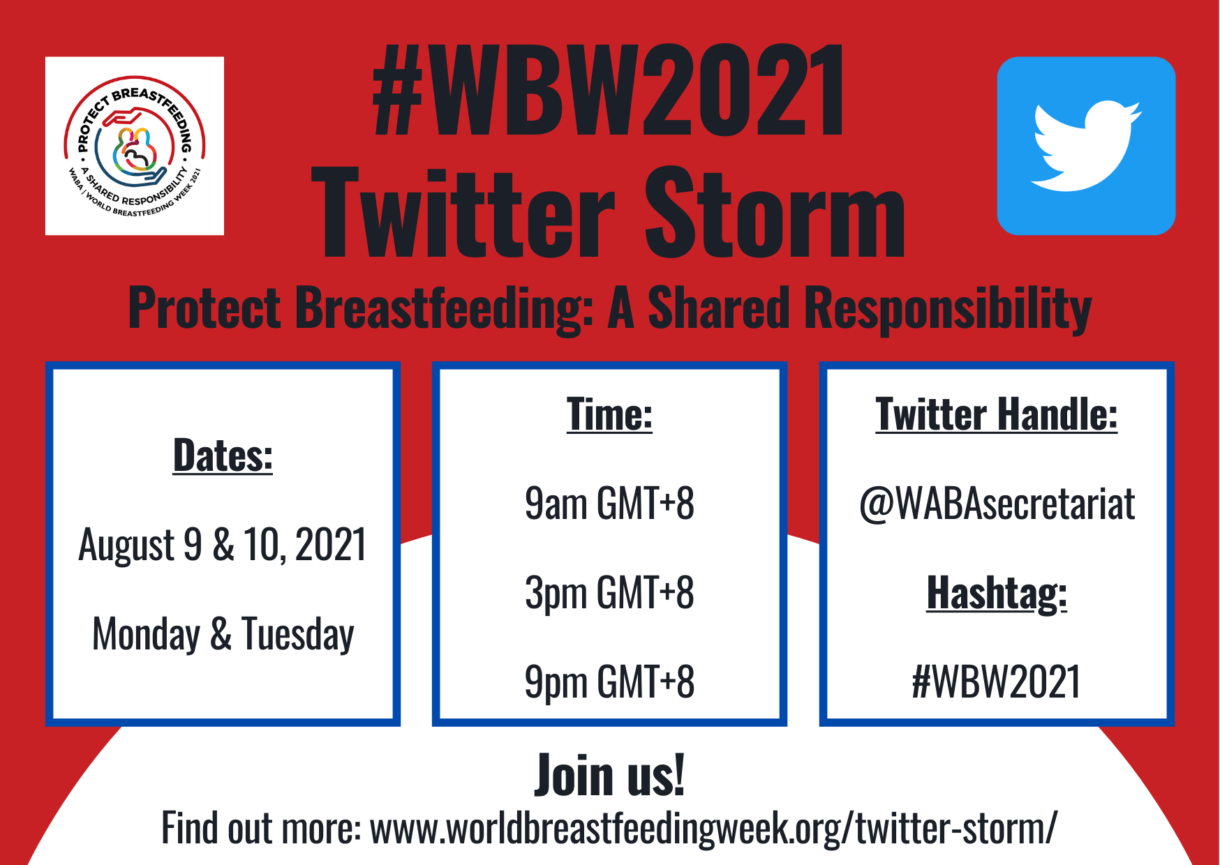

INFORMATION ON THE #WBW2021 TWITTER STORM

- Join the Twitter Storm on August 9 & 10, 2021 at @WABAsecretariat
- There will be six Twitter Storm sessions – at 9am GMT+8, 3pm GMT+8 and 9pm GMT+8 on August 9 & 10. You can join any session, depending on your availability
- Each session will be held for 1 hour and there will be a total of 6 tweets – one tweet every 10 minutes
- WABA will post a tweet, then participating organisations/individuals can retweet our post either on its own or with your accompanying post
- Always remember to tag us (@WABAsecretariat) and use our hashtag (#WBW2021) – we will retweet your posts as deemed appropriate
- Your accompanying response/post must stay within Twitter’s 280 character limit, so it’s best to prepare your posts/visuals/links in advance. Use the Q&A grid below to help craft your answers
- View our Action Folder for more information on the campaign

Q&A GRID
Please respond to any or all these posts during Twitter Storm:

DAY 1: AUGUST 9, 2021
TWITTER STORM SLOT | TWITTER STORM POST (@WABAsecretariat will post) | YOUR ANSWER  (you/your organisation’s post)
SESSION 1  August 9  9am GMT+8 | A public health approach to breastfeeding, where governments and other stakeholders collaborate to create a multisectoral breastfeeding-friendly environment, is a vital part of protecting and supporting #breastfeeding.  What is needed to achieve this?  #WBW2021  @WABAsecretariat | <your post>  @WABAsecretariat  #WBW2021
 | Breastmilk substitute (BMS) companies are exploiting digital platforms to market their products to the public, a practice that has become apparent during the #COVID19 pandemic.  What can we do to curb this exploitation?  #WBW2021  @WABAsecretariat | <your post>  @WABAsecretariat  #WBW2021
 | The International Code of Marketing of Breastmilk Substitutes is as important today as it was 40 years ago.  Who should we involve in protecting #breastfeeding families from the unethical marketing of BMS?  #WBW2021  @WABAsecretariat | <your post>  @WABAsecretariat  #WBW2021
 | All health workers who provide maternal and child health services must be trained in #breastfeeding counselling, the Code and conflicts of interest.  Why is it important to train healthcare workers?  #WBW2021  @WABAsecretariat | <your post>  @WABAsecretariat  #WBW2021
 | Social protection for all parents in the formal and informal sector, including paid parental leave and workplace support, protects their breastfeeding rights.  What can be done to protect breastfeeding at the workplace?  #WBW2021  @WABAsecretariat | <your post>  @WABAsecretariat  #WBW2021
 | Unsupportive social norms, traditional feeding practices and aggressive BMS marketing at the community level often impede optimal #breastfeeding.  What needs to be done to overcome challenges to breastfeeding at the community level?  #WBW2021  @WABAsecretariat | <your post>  @WABAsecretariat  #WBW2021
SESSION 2  August 9  3pm GMT+8 | Community members/organisations have a shared responsibility to:  🤝Ensure continuity in support for #breastfeeding mothers and families by linking community breastfeeding groups with the health system🤝  #WBW2021  @WABAsecretariat | <your post>  @WABAsecretariat  #WBW2021
 | Decision-makers & health workers have a shared responsibility to:  💵Invest in #breastfeeding counselling and Code training for all health workers who provide maternal and child health services💵  #WBW2021  @WABAsecretariat | <your post>  @WABAsecretariat  #WBW2021
 | Governments & national actors have a shared responsibility to:  👩‍🔧👩‍🌾Implement maternity and parental social protection legislation and workplace #breastfeeding support in both the formal and informal work sectors👩‍🌾👩‍🔧  #WBW2021  @WABAsecretariat | <your post>  @WABAsecretariat  #WBW2021
 | Employers, trade unions & workers have a shared responsibility to:  👩‍💻 Establish breastfeeding-friendly workplaces that are compliant with the Code👩‍💻  #WBW2021  @WABAsecretariat | <your post>  @WABAsecretariat  #WBW2021
 | Decision-makers & health workers have a shared responsibility to:  🙅‍♀️Advocate to national health associations and institutions to stop receiving support or sponsorship from BMS industries🙅‍♀️  #WBW2021  @WABAsecretariat | <your post>  @WABAsecretariat  #WBW2021
 | Community members/organisations have a shared responsibility to:  🗣️Build capacity of community #breastfeeding groups to provide ongoing support for families through both face2face and digital platforms🗣️  #WBW2021  @WABAsecretariat | <your post>  @WABAsecretariat  #WBW2021
SESSION 3  August 9  9pm GMT+8 | When health systems implement the BFHI Ten Steps, there is a positive impact on breastfeeding.  Speak up to protect #breastfeeding, tell us what YOU think can be done to improve implementation of the Ten Steps!  #WBW2021  @WABAsecretariat | <your post>  @WABAsecretariat  #WBW2021
 | Regulation/monitoring of BMS marketing are vital as the BMS industry regularly violates the Code all over the world, especially during a crisis.  Speak up to protect #breastfeeding, tell us what YOU think can be done to regulate/monitor BMS marketing!  #WBW2021  @WABAsecretariat | <your post>  @WABAsecretariat  #WBW2021
 | Parental social protection can be achieved through an effective partnership btw governments, employers & trade unions.  Speak up to protect #breastfeeding, tell us what YOU think can be done to ensure the protection of breastfeeding mothers/parents!  #WBW2021  @WABAsecretariat | <your post>  @WABAsecretariat  #WBW2021
 | @ilo Maternity Protection Convention C183 protects women in formal/informal work from economic losses/discrimination/health risks related to maternity.  Speak up to protect #breastfeeding, tell us what YOU think can be done to uphold the Convention!  #WBW2021  @WABAsecretariat | <your post>  @WABAsecretariat  #WBW2021
 | Physical/virtual community groups can provide support for the breastfeeding dyad & protect breastfeeding by being vigilant about BMS promotion/marketing.  Speak up to protect #breastfeeding, tell us what YOU think can be done to monitor BMS industries!  #WBW2021  @WABAsecretariat | <your post>  @WABAsecretariat  #WBW2021
 | Creating a Warm Chain across the continuum of care by providing consistent messages & good referral systems = breastfeeding families receive ongoing/timely support.  Speak up to protect #breastfeeding, tell us how YOU can be part of the warm chain!  #WBW2021  @WABAsecretariat | <your post>  @WABAsecretariat  #WBW2021

DAY 2: AUGUST 10, 2021

TWITTER STORM SLOT | TWITTER STORM POST (@WABAsecretariat will post) | YOUR ANSWER  (you/your organisation’s post)
SESSION 4  August 10  9am GMT+8 | A public health approach to breastfeeding, where governments and other stakeholders collaborate to create a multisectoral breastfeeding-friendly environment, is a vital part of protecting and supporting #breastfeeding.  What is needed to achieve this?  #WBW2021  @WABAsecretariat | <your post>  @WABAsecretariat  #WBW2021
 | Breastmilk substitute (BMS) companies are exploiting digital platforms to market their products to the public, a practice that has become apparent during the #COVID19 pandemic.  What can we do to curb this exploitation?  #WBW2021  @WABAsecretariat | <your post>  @WABAsecretariat  #WBW2021
 | The International Code of Marketing of Breastmilk Substitutes is as important today as it was 40 years ago.  Who should we involve in protecting #breastfeeding families from the unethical marketing of BMS?  #WBW2021  @WABAsecretariat | <your post>  @WABAsecretariat  #WBW2021
 | All health workers who provide maternal and child health services must be trained in #breastfeeding counselling, the Code and conflicts of interest.  Why is it important to train healthcare workers?  #WBW2021  @WABAsecretariat | <your post>  @WABAsecretariat  #WBW2021
 | Social protection for all parents in the formal and informal sector, including paid parental leave and workplace support, protects their breastfeeding rights.  What can be done to protect breastfeeding at the workplace?  #WBW2021  @WABAsecretariat | <your post>  @WABAsecretariat  #WBW2021
 | Unsupportive social norms, traditional feeding practices and aggressive BMS marketing at the community level often impede optimal #breastfeeding.  What needs to be done to overcome challenges to breastfeeding at the community level?  #WBW2021  @WABAsecretariat | <your post>  @WABAsecretariat  #WBW2021
SESSION 5  August 10  3pm GMT+8 | Community members/organisations have a shared responsibility to:  🤝Ensure continuity in support for #breastfeeding mothers and families by linking community breastfeeding groups with the health system🤝  #WBW2021  @WABAsecretariat | <your post>  @WABAsecretariat  #WBW2021
 | Decision-makers & health workers have a shared responsibility to:  💵Invest in #breastfeeding counselling and Code training for all health workers who provide maternal and child health services💵  #WBW2021  @WABAsecretariat | <your post>  @WABAsecretariat  #WBW2021
 | Governments & national actors have a shared responsibility to:  👩‍🔧👩‍🌾Implement maternity and parental social protection legislation and workplace #breastfeeding support in both the formal and informal work sectors👩‍🌾👩‍🔧  #WBW2021  @WABAsecretariat | <your post>  @WABAsecretariat  #WBW2021
 | Employers, trade unions & workers have a shared responsibility to:  👩‍💻 Establish breastfeeding-friendly workplaces that are compliant with the Code👩‍💻  #WBW2021  @WABAsecretariat | <your post>  @WABAsecretariat  #WBW2021
 | Decision-makers & health workers have a shared responsibility to:  🙅‍♀️Advocate to national health associations and institutions to stop receiving support or sponsorship from BMS industries🙅‍♀️  #WBW2021  @WABAsecretariat | <your post>  @WABAsecretariat  #WBW2021
 | Community members/organisations have a shared responsibility to:  🗣️Build capacity of community #breastfeeding groups to provide ongoing support for families through both face2face and digital platforms🗣️  #WBW2021  @WABAsecretariat | <your post>  @WABAsecretariat  #WBW2021
SESSION 6  August 10  9pm GMT+8 | When health systems implement the BFHI Ten Steps, there is a positive impact on breastfeeding.  Speak up to protect #breastfeeding, tell us what YOU think can be done to improve implementation of the Ten Steps!  #WBW2021  @WABAsecretariat | <your post>  @WABAsecretariat  #WBW2021
 | Regulation/monitoring of BMS marketing are vital as the BMS industry regularly violates the Code all over the world, especially during a crisis.  Speak up to protect #breastfeeding, tell us what YOU think can be done to regulate/monitor BMS marketing!  #WBW2021  @WABAsecretariat | <your post>  @WABAsecretariat  #WBW2021
 | Parental social protection can be achieved through an effective partnership btw governments, employers & trade unions.  Speak up to protect #breastfeeding, tell us what YOU think can be done to ensure the protection of breastfeeding mothers/parents!  #WBW2021  @WABAsecretariat | <your post>  @WABAsecretariat  #WBW2021
 | @ilo Maternity Protection Convention C183 protects women in formal/informal work from economic losses/discrimination/health risks related to maternity.  Speak up to protect #breastfeeding, tell us what YOU think can be done to uphold the Convention!  #WBW2021  @WABAsecretariat | <your post>  @WABAsecretariat  #WBW2021
 | Physical/virtual community groups can provide support for the breastfeeding dyad & protect breastfeeding by being vigilant about BMS promotion/marketing.  Speak up to protect #breastfeeding, tell us what YOU think can be done to monitor BMS industries!  #WBW2021  @WABAsecretariat | <your post>  @WABAsecretariat  #WBW2021
 | Creating a Warm Chain across the continuum of care by providing consistent messages & good referral systems = breastfeeding families receive ongoing/timely support.  Speak up to protect #breastfeeding, tell us how YOU can be part of the warm chain!  #WBW2021  @WABAsecretariat | <your post>  @WABAsecretariat  #WBW2021

